
NAME:
Ahmad Raza (53302)

PROGRAM:
BSSE-5

COURSE:
SDA

PROJECT:
Sales Point

SUBMITTED TO:
Dr. Muhammad Adnan
Contents
- Modelling and Analysis
  - Overview.
  - Background.
  - Functional Requirements.
  - Non-Functional Requirements.

- Modelling and Analysis
  - Use Case Diagram.
  - Class Diagram.
  - Sequence Diagram.
  - ERD

- Design Principles
  - SOLID Principles

- Architectural Design
  - Layered Architecture.
  - Repository Architecture.

- Code Design
  - Creational Design Pattern.
  - Structural Design Pattern.
  - Behavioural Design Pattern.

- Prototyping

- Modelling and Analysis

  - Overview:
The Sales Management (Sale-Point) System is a software platform designed to automate and improve day-to-day sales operations for a shop/business by managing products, customers, carts, orders, payments, employees, and customer complaints in one system. It provides separate functionalities for Admin, Customer, and Employee: the admin manages employees, salaries, products, orders, and complaint responses; the customer views products, adds items to cart, places orders, makes payments, and submits complaints; and the employee assists customers during the sales process. The system also maintains complete sales records through linked data entities such as Order, OrderItem, Product, Payment, and Complaint to ensure tracking from purchase to after-sales support.

  - Background:
The Sales Management (Sale-Point) System is developed to solve common problems in manual or semi-manual sales handling, such as inaccurate inventory updates, slow billing/checkout, scattered order records, and weak complaint handling. By centralizing operations and product catalog control, cart and order processing, payment recording (cash/card/online), and complaint submission/response,the system improves accuracy, efficiency, and customer service quality. This approach also supports better administration by allowing structured management of employees and order statuses (list/complete/cancel), using a clear database model and class-based design for maintainability and future expansion.

  - Functional Requirements:
- User Authentication:
- Provide secure login functionality for Admin and Customer to access permitted features (e.g., product management for admin, purchasing for customer).

- Product Management:
- Enable Admin to add, update, delete products and view the product list for inventory control.
- Allow Customers to browse/view products with details such as name, price, and available quantity.

- ​Cart Management:
- Allow Customers to add products to cart, remove products from cart, view cart, and proceed to checkout.

- Order Processing:
- Facilitate order placement for Customers after checkout, and store order details such as total amount, date, and status.
- ​Enable Admin to manage orders by listing orders, completing orders, and canceling orders.

- ​Payment Processing:
- Support multiple payment options (Online, Cash, Card) for Customers.
- ​Store payment details including payment type and amount linked to the relevant order.

- Invoice/Receipt Generation:
- Generate an invoice/receipt after successful payment as part of the checkout flow.

- Employee Management:
- Enable Admin to add employee, update employee, remove employee, and manage salary.

- Customer Assistance:
- Allow Employees to assist customers during the order/purchasing process.

- Complaint Management:
- Enable Customers to register/submit complaints with comments linked to the related customer and order.
- Allow Admin to view complaints and respond to complaints.

  - Non-Functional Requirements:
- Performance:
- Ensure the system can handle multiple simultaneous users without delays.
- Maintain fast response times for all system actions and queries.

- Security:
- Implement secure authentication and role-based access control.
- Encrypt sensitive data, such as payment details and user credentials.
- Perform regular security checks and updates.

- Usability:
- Design intuitive, user-friendly interfaces for all user roles.
- Ensure compliance with web accessibility standards to cater to diverse users.

- Reliability:
- Guarantee high system availability and minimize downtime.
- Implement periodic data backups to prevent data loss.

- Scalability:
- Ensure the system can accommodate growing user bases and data volumes.
- Use a modular design to support future feature expansion and upgrades.

- Compatibility:
- Ensure the system works seamlessly across different browsers and platforms.
- Use a responsive design to optimize the experience for both mobile and desktop users.

- Maintainability:
- Provide comprehensive documentation for system maintenance and updates.
- Follow clean coding practices to simplify troubleshooting and future development.

- Modelling and Analysis

  - UseCase Diagram:
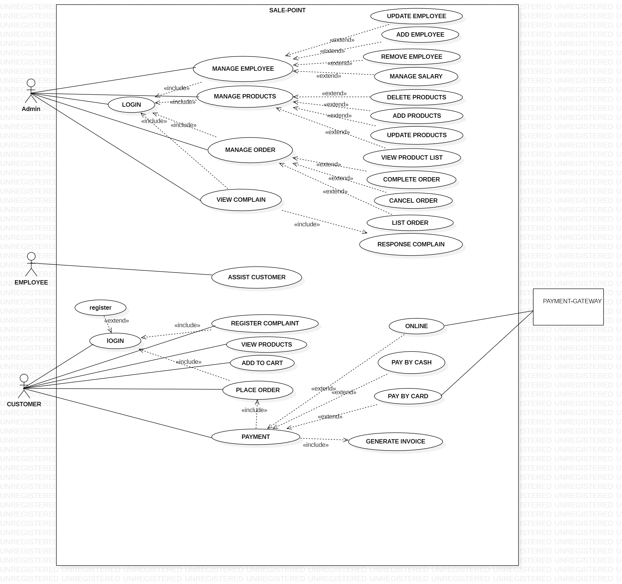

  - Class Diagram: 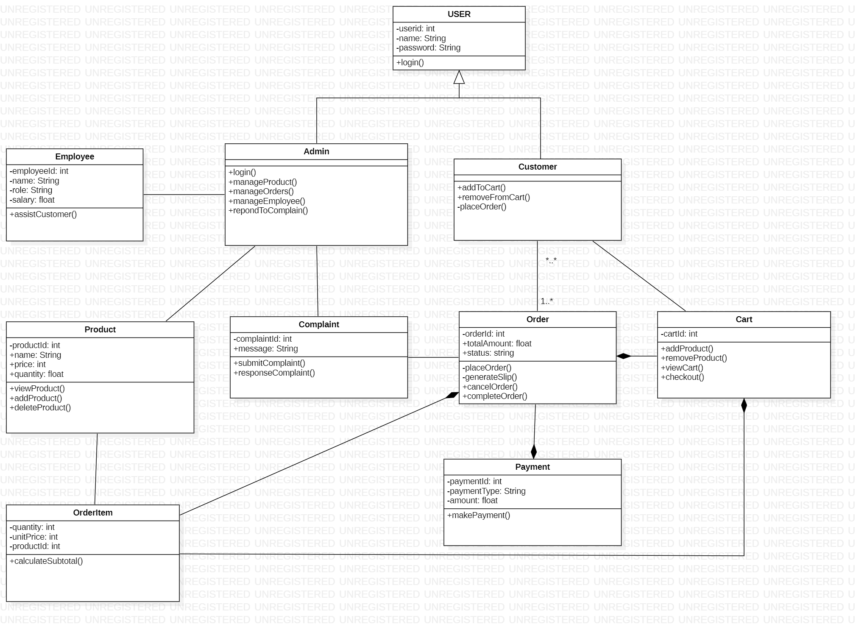

  - Sequence Diagram:
2.3.1 Admin Side Sequance Diagram: 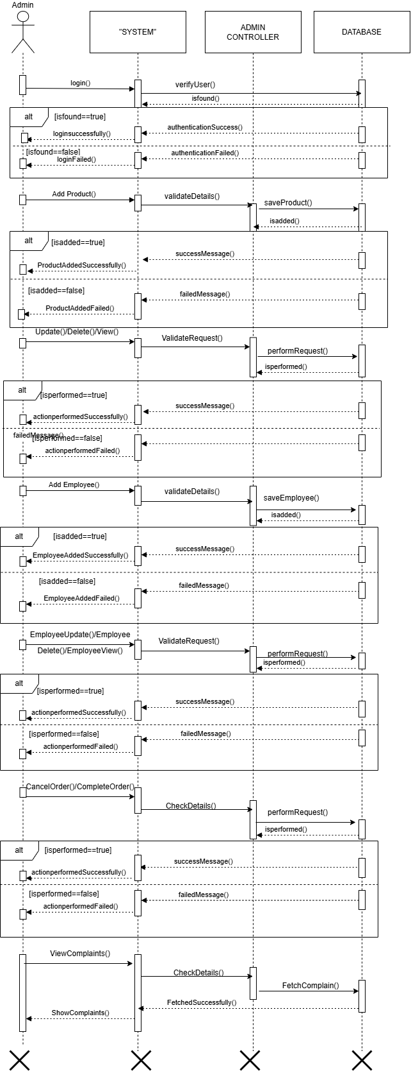

2.3.2 Customer Side Sequance Diagram: 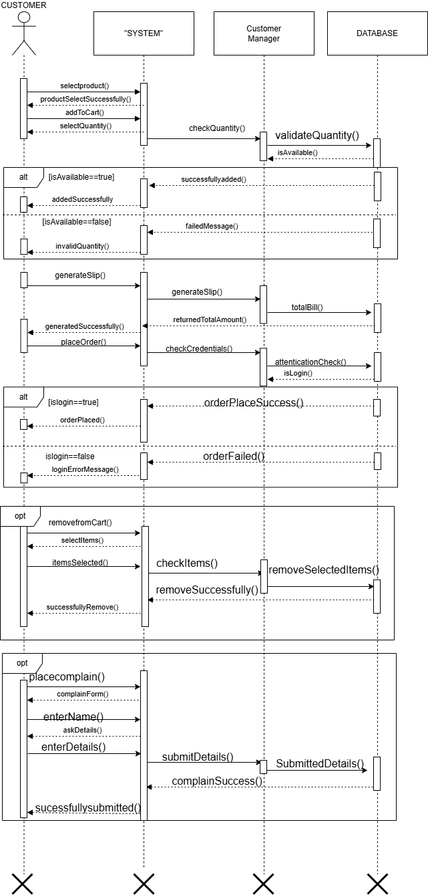

  - ERD: 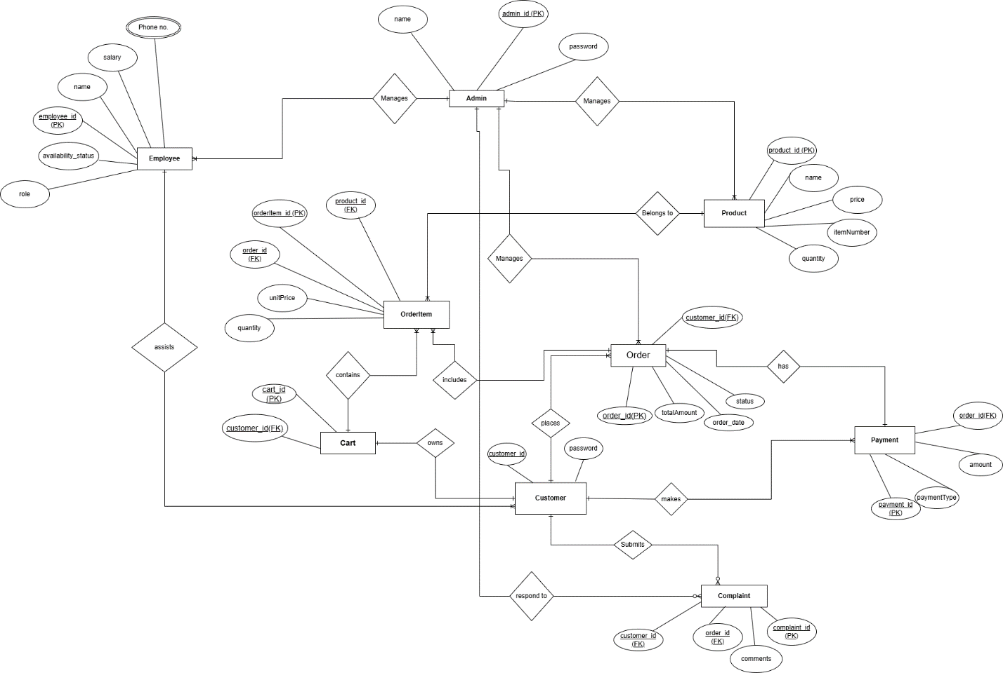

  - Architecture Diagram:

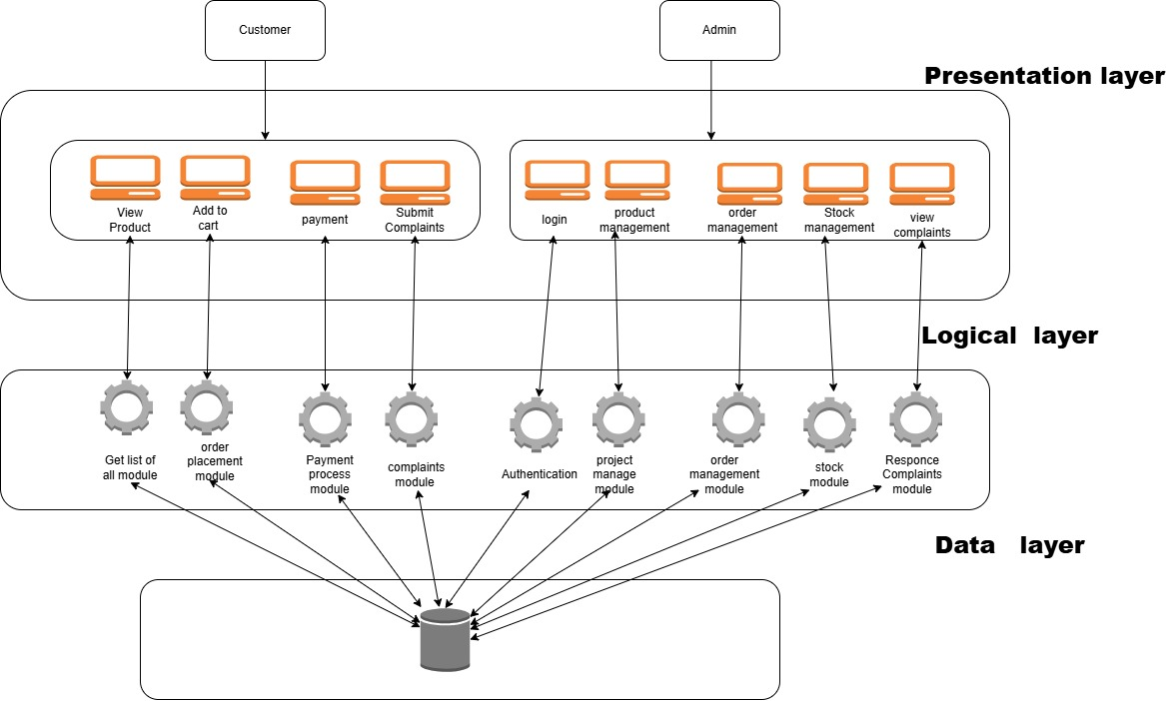

- Design Principles
3.1. S.O.L.I.D Principles:
SOLID principles are a set of five design principles intended to make software designs more understandable, flexible, and maintainable. These principles include:
- S - Single Responsibility Principle (SRP).
- O - Open/Closed Principle (OCP).
- L - Liskov Substitution Principle (LSP).
- I - Interface Segregation Principle (ISP).
- D - Dependency Inversion Principle (DIP).

SOLID Principles in Our Sales Management System
The design of the Sales Management System follows the five SOLID object-oriented design principles to ensure the system remains flexible, scalable, and easy to maintain.
- Single Responsibility Principle (SRP):
“A class should have only one reason to change.”
In our system, every class is assigned a single, clear responsibility:
- Customer handles shopping activity such as adding items to cart and placing orders.
- Cart is responsible only for storing selected items temporarily.
- Order records finalized purchases and order status.
- OrderItem represents a single product with quantity within a cart or order.
- Product manages product information such as name, price and stock.
- Payment handles payment information.
- Complaint stores and tracks customer issues.
- Admin manages system-level data such as employees, products, and orders.
- Employee is dedicated to customer assistance.
By separating responsibilities, each class is easier to understand, update, test, and modify without affecting unrelated functionality.
- Open/Closed Principle (OCP):
“Software components should be open for extension but closed for modification.”
Our design allows features to be expanded without changing core classes:
- We can add new payment methods (e.g., bank transfer, QR code) by extending the Payment class rather than modifying it.
- Additional modules like discounts, reward points, delivery, or tax calculation can be added using new classes without changing the Order class.
- Products, employees, and complaints can grow with new fields or behaviors using extension instead of altering existing logic.
This ensures business growth does not require rewriting stable components.
- Liskov Substitution Principle (LSP):
“Objects of a derived class should be usable in place of objects of the base class.”
In our project:
- Admin, Customer, and Employee all inherit from the User parent class.
- Any operation expecting a User can safely work with any of its child types.
- For example, if later we add a Supplier user role, it can plug into the same inheritance structure.
This ensures proper use of polymorphism and avoids tight coupling between classes.
- Interface Segregation Principle (ISP)
“Classes should not be forced to depend on methods they do not use.”
Although explicit interfaces are not implemented, our design follows ISP conceptually:
- The Customer class only performs customer-related tasks (add to cart, place order, register complaint).
- The Admin does not perform customer actions but handles system administration.
- Employee focuses solely on customer assistance.
- No class holds irrelevant methods belonging to another role.
Each actor interacts only with the functions they require, avoiding bloated classes.
- Dependency Inversion Principle (DIP):
“Depend on abstractions, not concrete implementations.”
Our design minimizes direct dependencies between classes:
- Order does not depend directly on Product, instead it interacts via OrderItem, which decouples order details from the product catalog.
- Payment is loosely associated with Order, allowing different payment processes without modifying Order logic.
- Customer interacts with Cart and Order through high-level methods, not by manipulating item lists directly.
Abstracting behavior creates a loosely coupled system where changes in one area do not break another.

Architectural Design

4.1. Layered Architecture (Primary Architecture)
The Sales Management System follows a Layered Architecture, which divides the application into logical layers where each layer has clearly defined responsibilities.
This structure improves system maintainability, scalability, and modifiability.

Layers in the System
- Presentation Layer (User Interface):
  - This layer is responsible for all user interactions.
  - Interfaces for customer and admin users are handled here.
  - It displays products, receives customer orders, and presents admin controls for inventory and reports.
- Application Layer (Business Logic):
  - Contains the core business rules and processes.
  - Responsible for executing system workflows such as:
    - Adding or updating products,
    - Managing stock quantities,
    - Creating and validating orders,
    - Generating order totals and invoices.
  - Ensures that system rules (e.g., “product quantity cannot be negative”) are enforced.
- Data Access Layer:
  - Manages all storage and retrieval of application data.
  - Responsible for database operations such as:
    - Saving customer orders,
    - Updating inventory quantity after purchase,
    - Storing product catalog and order details.
  - Acts as a bridge between the business layer and data repository.
- Database Layer (Repository):
  - Stores all persistent data centrally (e.g., Products, Orders, OrderItems, Customer Names).
  - Serves as the “single source of truth” accessed by all other layers.
  - Ensures that all modules read from and write to consistent data.

4.2. Repository Architecture (Data Organization Style)
The system also follows a Repository Style for data management alongside the layered architecture.

Characteristics:
- All application data (products, orders, order items) is stored in a central database repository.
- Multiple components access the same data source:
  - Customers read products and place orders.
  - Admin updates stock and adds new products.
- This ensures:
  - Data consistency
  - Reduced duplication
  - Simplified data management
  - Easy data sharing across system modules

Why These Architectures Are Suitable
- The project has two different roles (Customer and Admin) using shared data.
- System activities include:
  - Product browsing
  - Cart/Order creation
  - Stock updates
  - Invoice generation
- Layered architecture supports easy upgrade and maintenance
- Repository architecture maintains data accuracy and integrity
- Together, they allow smooth handling of sales transactions and inventory control.

Benefits Provided:
Benefit | Explanation
Maintainability | Layers separate concerns, making the system easier to modify and extend.
Scalability | Additional data or features (discounts, refunds, branches) can be added without redesigning the system.
Reusability | Core business logic can be reused across different user interfaces (web, mobile, POS).
Data Consistency | Shared repository ensures that all users work with up-to-date information.
Security and Validation | Validation rules in the business layer prevent invalid data updates.

Conclusion:
The Sales Management System is best supported by:

Layered Architecture (Main Structure)

Central Repository Architecture (Data Management)
This architectural combination ensures reliability, clean modular separation, and efficient operation across customer and admin interactions.

Design Patterns

5.1. Creational Design Patterns
Creational design patterns abstract the object creation process and make the system design more flexible and reusable.

1. Singleton Pattern:
The Singleton Pattern ensures a class has only one instance and provides a global access point to it.

Application in Sales Management System
The DatabaseConnection or InventoryService follows the Singleton pattern.
There should be only one instance managing access to the Product and Order database to:
- Avoid duplicated records,
- Prevent conflicting product updates,
- Maintain consistent real-time stock management.

How it Works
- When the system needs data access, getInstance() checks whether an existing connection/service object exists.
- If not, it creates one.
- If yes, it returns the single instance.
This ensures all modules (Customer ordering, Admin updating stock) use the same shared resource.

2. Factory Pattern:
The Factory Pattern defines an interface to create objects while allowing subclasses to decide which object to instantiate.

Application
The system may require creation of different user role objects:
- AdminUser
- CustomerUser or GuestUser
(The customer role can be treated as a guest or lightweight user.)

Implementation
- A UserFactory receives a user-role input.
- Based on the role, it returns an object of the corresponding class.
- This centralizes object creation and avoids dependency on concrete classes.
This makes it easy to add new roles later (e.g., Cashier or Branch Manager) without modifying existing login code.

3. Builder Pattern:
Builder Pattern is used when a complex object must be constructed step-by-step.

Application
The Order object is best suited for Builder:
- An order may contain multiple data layers:
  - Customer Name
  - Order ID
  - List of Order Items
  - Total amount
  - Timestamp
  - Payment Method (future enhancement)
  - Applied coupons (optional future)

Implementation
- Start by adding basic order details (customer name & timestamp)
- Add OrderItems (productId + quantity)
- Calculate final total
- Build the final Order object only when everything is ready
This clearly separates order creation steps and ensures no incomplete order enters the system.

5.2. Structural Design Patterns
Structural patterns manage object composition to ensure the system remains flexible even if internal parts change.

1. Facade Pattern:
Facade provides a simple interface to complex subsystems.

Application
Your Customer Screen UI acts as a Facade:
- The user only sees:
  - View Products
  - Add to Cart
  - Place Order
- Internally:
  - Business logic calculates totals
  - Stock validation runs
  - Database updates inventory
  - OrderItems are inserted
The user does not interact with internals—only the facade.

2. Adapter Pattern:
The Adapter Pattern allows incompatible interfaces to work together.

Application
When loading product lists or order history:
- The database returns raw records (documents/rows)
- UI needs a display list or table model

Implementation
An Adapter converts:
- Product database objects → Display objects (card/list tile)
- OrderItems → receipt format
This ensures UI changes don’t break database logic.

3. Composite Pattern (optional but applicable):
Composite pattern treats individual objects and groups uniformly.

Application
Your Cart and Order work like a composite:
- Cart contains multiple OrderItems
- Each OrderItem refers to a single product + its quantity
Even though there are multiple items, the cart behaves as one entity during:
- Total calculation
- Stock deduction
- Checkout

5.3. Behavioral Design Patterns
Behavioral patterns control communication between objects and define how responsibilities are distributed.

1. Observer Pattern:
Observer notifies dependent objects when a subject’s state changes.

Application
The system can apply Observer logic to:
- Inventory changes after an order is placed
- Admin dashboard updating list of low-stock products

Example
- Subject: Product quantity
- Observer: Admin’s inventory monitoring screen
Whenever quantity changes, admin sees updated levels.

2. Command Pattern:
Encapsulates requests as objects so they can be parameterized and reused.

Application
Admin panel buttons perform different tasks:
- Add Product
- Update Stock
- Remove Product
- Generate Sales Report
Each button triggers a separate command method:
- addProductCommand()
- updateStockCommand()
- etc.
This cleanly separates UI input from business actions.

3. Strategy Pattern:
Defines multiple interchangeable algorithms.

Application
Order validation uses Strategy logic:
- Strategy 1: Check requested quantity ≤ available quantity
- Strategy 2: Compute subtotal for each item
- Strategy 3: Calculate final total with tax (future enhancement)
If additional rules are needed (e.g., loyalty points, coupons), new strategies can be plugged in without rewriting code.

